**LLM Data Exchange Platform: Connecting Organizations and Content Creators**

**Problem Statement**

**Challenge:** Training large language models (LLMs) relies heavily on vast amounts of data scraped from third-party websites and social media platforms. This approach presents several issues:

* **Accuracy:** The quality and accuracy of scraped data can be inconsistent. There's a risk of encountering irrelevant information, misinformation, or biased content.
* **Cost:** Organizations often incur licensing fees for accessing data from third-party providers.
* **Control:** Limited control over the data source restricts tailoring content specifically for LLM training needs.

**Proposed Solution: Broker Application for Direct Data Exchange**

We propose a broker application that facilitates a direct connection between organizations looking to train LLMs and content creators with relevant data (text, images, and videos). This platform would address the challenges outlined above by:

* **Improving Accuracy:** Content creators can tailor data specifically for LLM training purposes, ensuring its relevance and reducing the risk of bias or misinformation.
* **Reducing Costs:** The platform would eliminate the need for expensive third-party data licensing fees, creating a more cost-effective solution for both parties.
* **Enhancing Control:** Organizations can set specific criteria for the type and format of data they require, fostering greater control over the training process.

**Benefits:**

* **Content Creators:** Gain a new revenue stream by monetizing their data.
* **Organizations:** Access high-quality, tailored data at a lower cost.
* **LLM Development:** Advancements in LLM development through access to more reliable and relevant training data.

By implementing this solution, organizations can overcome the hurdles associated with current data acquisition methods, ultimately leading to the development of more accurate and reliable LLMs.

**High-Level System Design for Broker Application**

This high-level design focuses on the core functionalities of the application that connects organizations and content creators for LLM training data exchange.

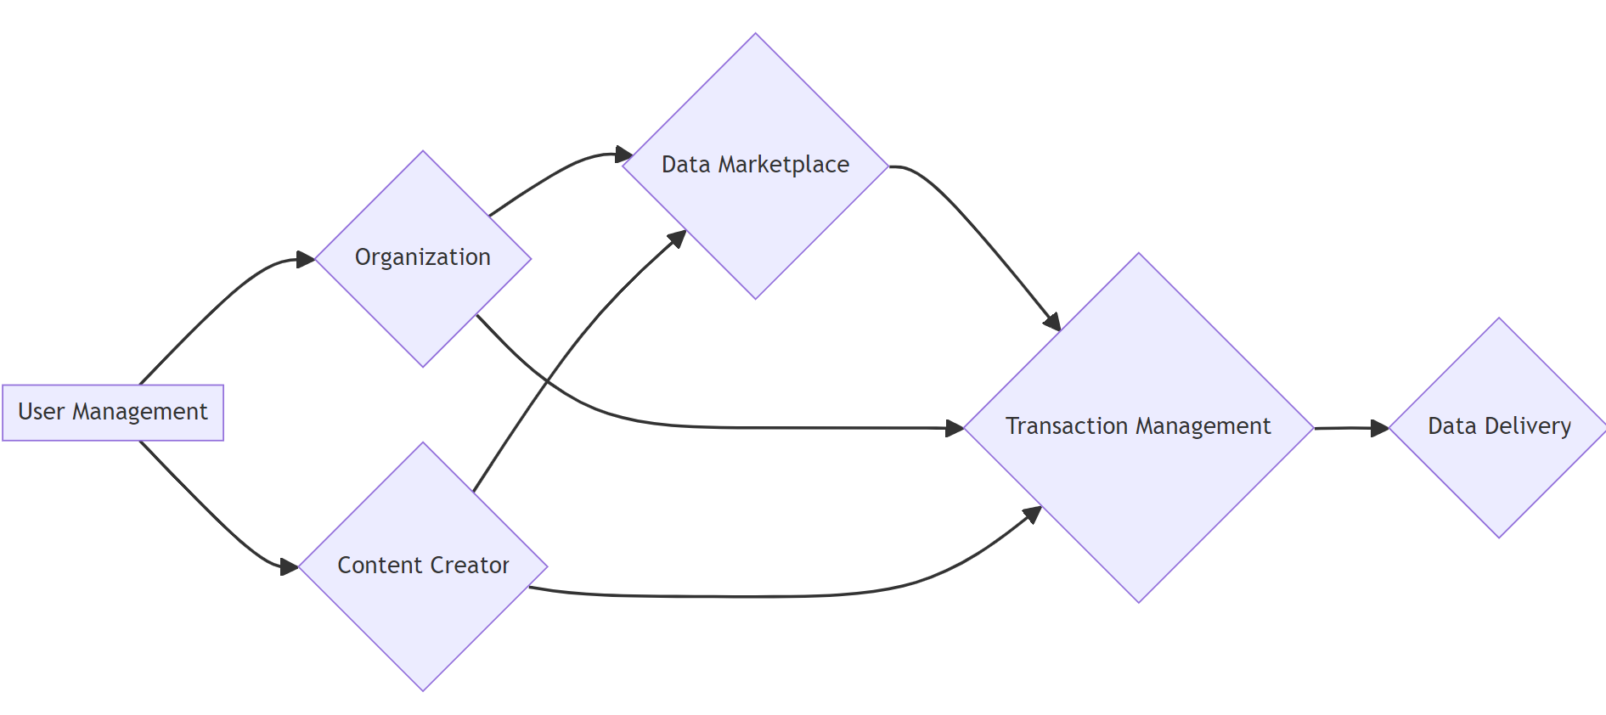

**Components:**

1. **User Management:**
   * Handles user registration and login for both organizations and content creators.
   * Stores user profiles with relevant information (e.g., organization type, data expertise for creators).
2. **Data Marketplace:**
   * Content creators can expose their data (text, image, video) with annotations and descriptions relevant to LLM training.
   * Organizations can browse and search for data based on specific needs (e.g., topic, format, language).
   * Implement a secure storage solution for uploaded data.
3. **Transaction Management:**
   * Facilitates negotiation and agreement between organizations and creators on data pricing and licensing terms.
   * Secure payment processing system to handle transactions.
4. **Data Delivery:**
   * Provides a secure mechanism for organizations to download purchased data.
   * Consider options like direct download or cloud storage access.

**Communication:**

* Organizations and creators can communicate directly through the platform for discussions and negotiations.
* A messaging system can be implemented for secure communication.

**Security:**

* Secure user authentication and authorization.
* Data encryption at rest and in transit.
* Implement access controls to restrict unauthorized data access.

**Scalability:**

* Design the system to handle a growing number of users and data volume.
* Consider a distributed architecture with cloud-based storage and processing capabilities.

.